Applying ML and DL algorithms

The detection of the artifacts resembling to the presence of Pneumonia and Covid in the chest x-ray data acquired for the work is performed by leveraging convolutional neural networks. The data of the chest x-rays has been acquired from [1] which contains Chest X-Ray images of different dimensions. But predominantly for our research all the images were pre-processed to a size of 224 X 224 px for maintaining a proper aspect ratio among all the images as all the images were having different dimensions and moreover, we also tried to maintain the information gain from all the images consistently. For instance, Figure 1 shows the images that were used in the experiment where one image is the one pertaining to pneumonia and the second being normal.

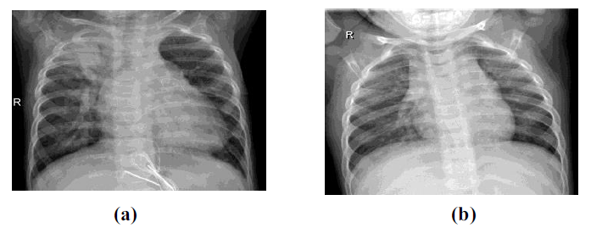

**Figure 1:** Images of Chest X-Rays. (a) Chest X-Ray having Pneumonia (b) Chest X Ray which is normal

**Classification of Pneumonia using ResNet50V2:**

ResNet50V2 is a modified version of ResNet50 that performs better than ResNet50 and ResNet101 on the ImageNet dataset. In ResNet50V2, a modification was made in the propagation formulation of the connections between blocks. ResNet50V2 also achieves a good result on the ImageNet dataset. The ResNet50V2 architecture consists of several residual blocks with each block having several convolutional operations. The implementation of skip connections makes the ResNet50V2 better than VGG. The skip connections between layers add the outputs from previous layers to the outputs of the stacked layers. This allows the training of deeper networks. One of the problems that ResNet50V2 solves is the vanishing gradient problem [2].

ResNet50V2 takes an image of size 224 × 224 pixels. Pre-processing of the images was performed automatically by calling ‘preprocess input’ from the ResNet50V2 model in TensorFlow. The ‘preprocess input’ is fed into the ‘ImageDataGenerator’ from TensorFlow (Keras). ‘ImageNet’ weights are used for training. Out of the 5,240 images, 80% of the images are used for training. The VisionPro Deep Learning suite automatically selects the other 20% images for validation. Both the training and validation sets are randomly selected by the VisionPro Deep Learning suite. The user just needs to specify the train validation split. The maximum number of epoch counts was selected to be 10. There are options of selecting the minimum epochs and patience for which the model will train, but this was not selected.

**Classification of COVID-19 using DenseNet121:**

DenseNet (Dense Convolutional Network) [3] is an architecture which focuses on making the Deep Learning networks go even deeper, while at the same time making them more efficient to train, using shorter connections between the layers. DenseNet is a convolutional neural network where each layer is connected to all other layers that are deeper in the network, that is, the first layer is connected to the 2nd, 3rd, 4th and so on, the second layer is connected to the 3rd, 4th, 5th and so on. It does not combine features through summation but combines the features by concatenating them. So, the ‘ith’ layer has ‘i’ inputs and consists of feature maps of all its preceding convolutional blocks. It therefore requires fewer parameters than traditional convolutional neural networks.

We also tested Desenet121 Deep Learning on a previous version of the COVID-19 dataset, which has a total of 4000 images. They were split into the following number of images in the training set: 220 images in the normal class and 2600 images in the COVID-19 class, and the following number of images in the test set of each class: 150 images in the Normal class 1400 images in the COVID-19 class.

*References:*

*[1]. Paul M (2020) Kaggle chest X-ray images (pneumonia) dataset. https://www.kaggle.com/paultimothymooney/chest-xray-pneumonia/*

*[2]. Veit A, Wilber M, Belongie S. Residual networks behave like ensembles of relatively shallow networks. (2016) In: Advances in neural information processing systems. Cambridge: MIT Press.*

*[3] S* *Huang G, Liu Z, Van Der Maaten L, Weinberger KQ. Densely connected convolutional networks. In: Proceedings—30th IEEE conference on computer vision and pattern recognition, CVPR 2017. (2017). https: //doi.org/10.1109/CVPR.2017.*